IT Support Team Performance Analytics

1. Project Overview
This project analyzes a large IT customer-support ticket dataset to understand ticket volume, issue categories, support queues, resolution performance, clustering patterns, geographic distribution, SLA conditions, and team performance. The final analytical output was developed as an interactive six-page Power BI dashboard.

2. Problem Statement
Large volumes of IT support tickets make it difficult to identify common issues, route tickets to suitable teams, monitor resolution performance, detect critical work, and understand geographic patterns. The project applies data analytics, text similarity, clustering, geographic analysis, and visualization to turn ticket data into useful operational insights.

3. Objectives
- Clean and prepare the support-ticket dataset.
- Analyze ticket distribution by category, priority, status, channel, product, queue, and region.
- Create Resolution_Duration, Priority_Score, Type, Queue, Similarity_Score, Performance_Score, Latitude, and Longitude.
- Group similar tickets using K-Means clustering.
- Compare resolution and performance across queues, priorities, regions, and clusters.
- Create geographic and category-level visualizations.
- Build an interactive Power BI dashboard for reporting and decision support.

4. Dataset and Tools
Item | Details
Dataset | Kaggle customer_support_tickets_200k.csv
Size | Approximately 200,000 tickets
Processing | Python / Jupyter Notebook
Libraries | Pandas, NumPy, scikit-learn, Matplotlib, Seaborn, Plotly
Text analysis | TF-IDF and cosine-similarity-based analysis
Clustering | K-Means
Dashboard | Microsoft Power BI
Final dataset | customer_support_tickets_final.csv

5. Main Dataset Fields
The final analytical dataset included ticket/customer fields plus engineered fields such as:
ticket_id, customer_name, customer_email, product, category, issue_description, resolution_notes, priority, status, channel, region, customer_age, customer_gender, subscription_type, customer_tenure_months, previous_tickets, customer_satisfaction_score, first_response_time_hours, resolution_time_hours, ticket_created_date, ticket_resolved_date, escalated, sla_breached, operating_system, payment_method, language, preferred_contact_time, issue_complexity_score, customer_segment, Type, Resolution_Duration, Priority_Score, Queue, Latitude, Longitude, Cluster, Similarity_Score, Performance_Score.

6. Data Preparation
- Loaded and explored the CSV using Pandas.
- Checked schema, data types, and missing values.
- Prepared date and numerical fields for analysis.
- Created derived fields required for routing, performance, clustering, similarity, and geographic analysis.
- Saved the processed dataset for Power BI.

7. Feature Engineering

7.1 Type Mapping
Category | Type
Account Suspension | Request
Performance Issue | Problem
Subscription Cancellation | Request
Feature Request | Request
Payment Problem | Incident
Security Concern | Incident
Refund Request | Request
Login Issue | Incident
Bug Report | Incident

7.2 Queue Mapping
Category | Queue
Login Issue | Technical Support
Account Suspension | Account Management
Payment Problem / Refund Request | Billing Support
Security Concern | Security Team
Bug Report | Development Team
Performance Issue | Infrastructure Team
Feature Request | Product Team

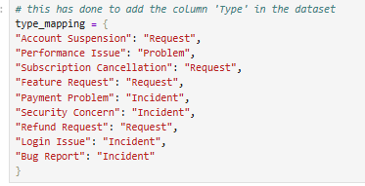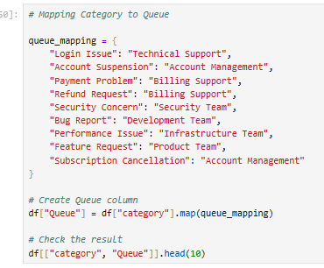

7.3 Other Engineered Features
- Resolution_Duration represents the time required to resolve a ticket.
- Priority_Score converts ticket priority into a numerical analytical feature.
- Latitude and Longitude support geographic visualizations.
- Similarity_Score supports similarity and cluster analysis.
- Performance_Score supports performance comparisons.

8. Similarity Analysis
Issue descriptions were converted into TF-IDF vectors so that textual information could be represented numerically. Similarity analysis was used to support grouping and comparison of similar support issues. For large datasets, a full pairwise similarity matrix for all 200K tickets was avoided in favor of more scalable vector-based analysis.
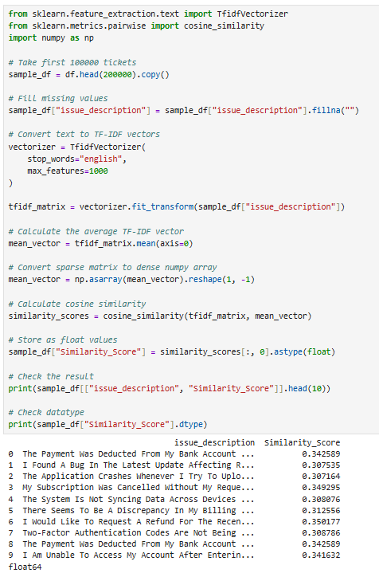

9. K-Means Clustering
K-Means was used to group tickets with similar analytical characteristics. Features considered in the project included category, priority, resolution time, similarity score, and queue. The elbow method was used to examine WCSS across candidate cluster counts.
- Cluster identifies the assigned ticket group.
- Cluster Distribution compares ticket counts between clusters.
- Cluster size was compared with performance-related measures.
- Similarity and performance measures support interpretation of cluster behavior.

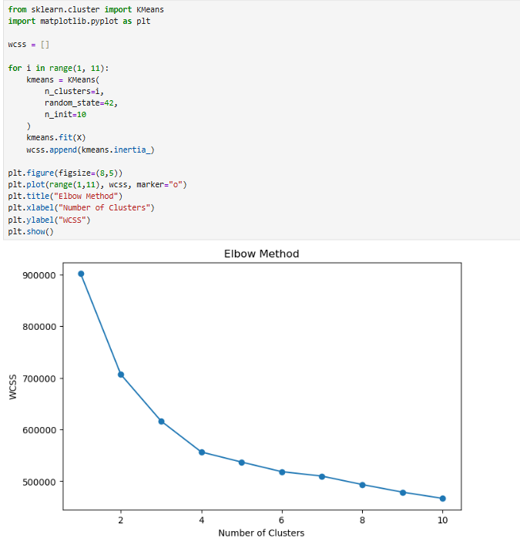

10. Geographic Analysis
- Added latitude and longitude using regional coordinate information.
- Created geographic visualizations of ticket distribution.
- Mapped issue categories geographically.
- Used regional comparisons together with performance measures.
- Created heatmap-style category-by-region analysis.

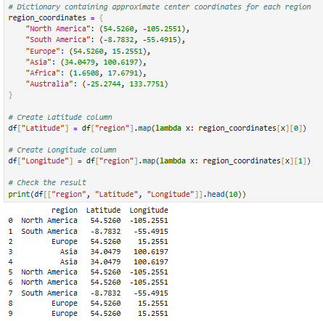

11. Milestone 1 – Data Preparation
- Loaded and explored the 200K-ticket dataset.
- Checked columns, data types, and data quality.
- Prepared the cleaned dataset.
- Created feature-engineering outputs.
- Prepared the data dictionary and feature summary.

12. Milestone 2 – Clustering and Support Analysis
- Identified frequent categories and clusters.
- Created Queue mappings for support teams.
- Applied similarity analysis to issue descriptions.
- Applied K-Means clustering.
- Compared cluster size, similarity, resolution performance, and issue characteristics.
- Prepared analytical visualizations.

13. Milestone 3
- Analyzed average resolution time by priority and support type/queue.
- Compared team and regional performance.
- Analyzed high-priority unresolved issues.
- Created performance metrics for reporting.
- Added latitude and longitude for regional mapping.
- Created geo-visualizations of ticket distribution.
- Mapped issue categories geographically.
- Analyzed cluster size versus performance score.
- Developed comparative charts and geographic insights.

14. Milestone 4
- Combine visual insights into an interactive Power BI or Streamlit dashboard
- Organize visualizations into performance KPIs: Average Resolution Time, Most Frequent Categories, Cluster Similarity Index, Top Performing Regions
- Finalize project report (PDF/README)
- Prepare presentation slides highlighting insights and recommendations
- Upload code, visuals, and report to GitHub
- Deliverables: Final visual dashboard, Comprehensive project documentation, Presentation slides

15. Power BI Dashboard Structure
Page | Purpose | Main Content
Overview | High-level summary | KPI cards, category/queue/performance insights
Tickets | Ticket analysis | Status, product, priority, channel and ticket KPIs
Clusters | Cluster analysis | Cluster distribution and cluster comparisons
Geography | Regional analysis | Maps and category-by-region insights
Performance | Team performance | Resolution time, performance, SLA and satisfaction
Reports | Consolidated reporting | Summary and comparative reporting

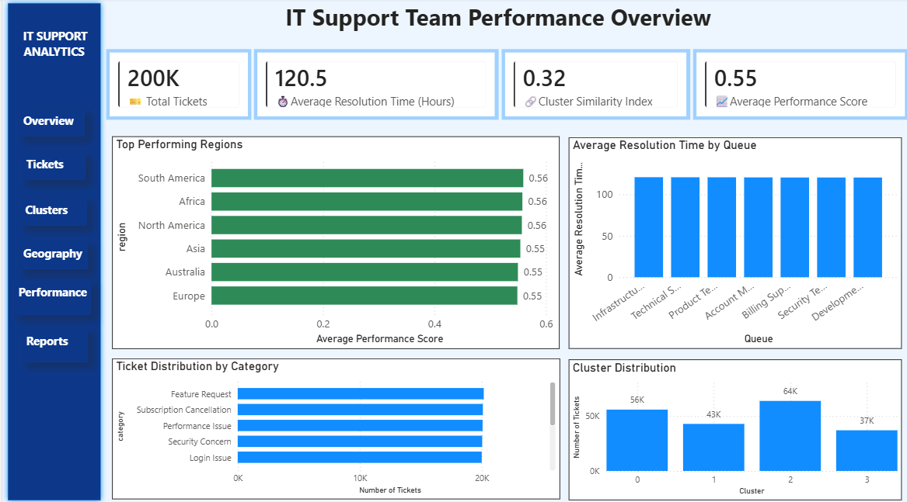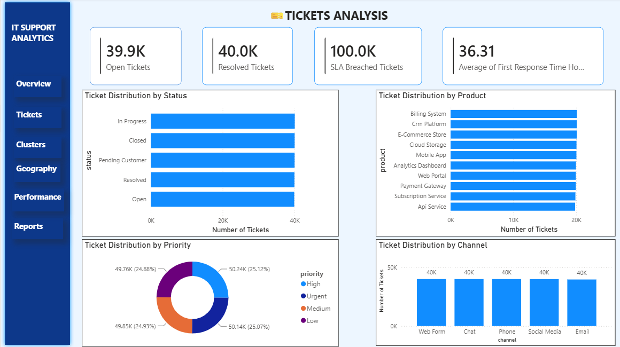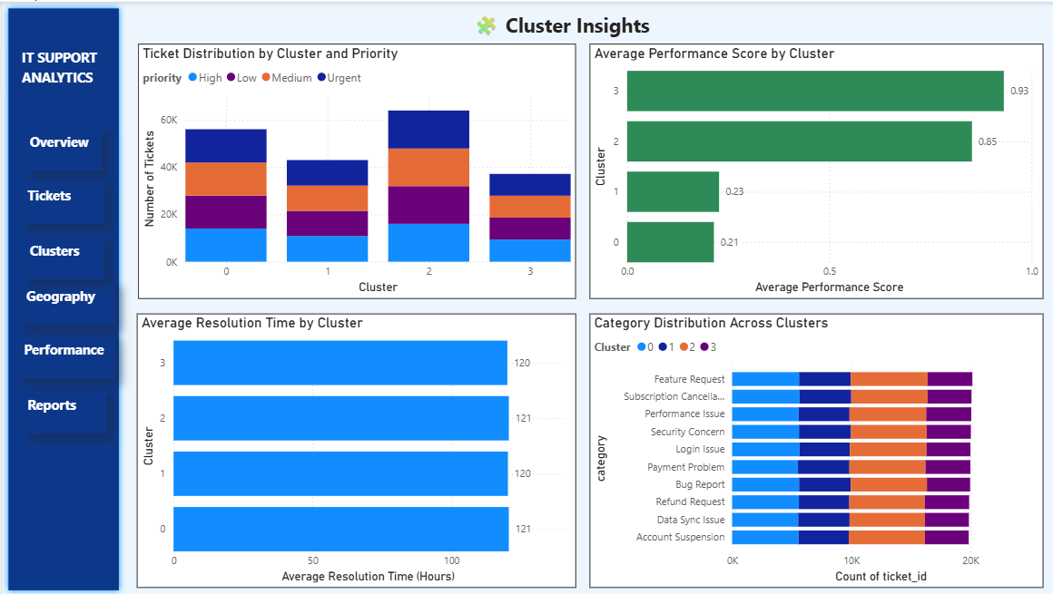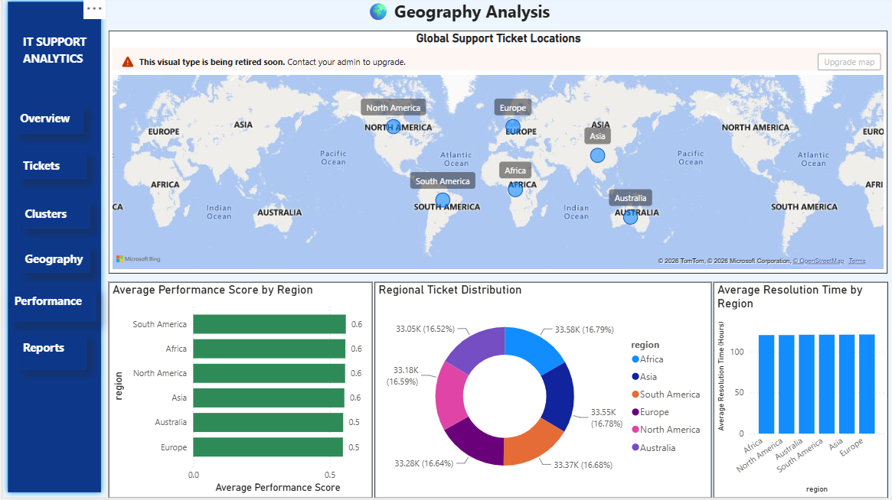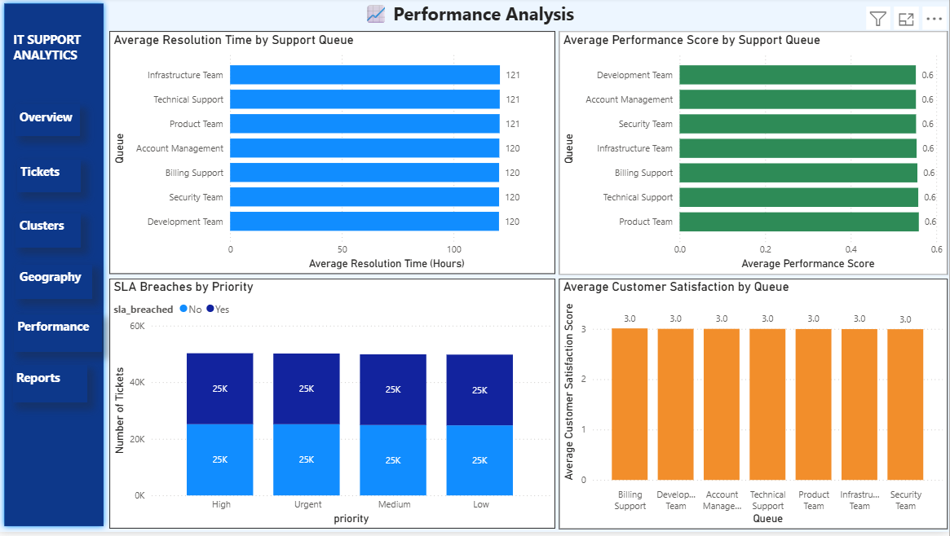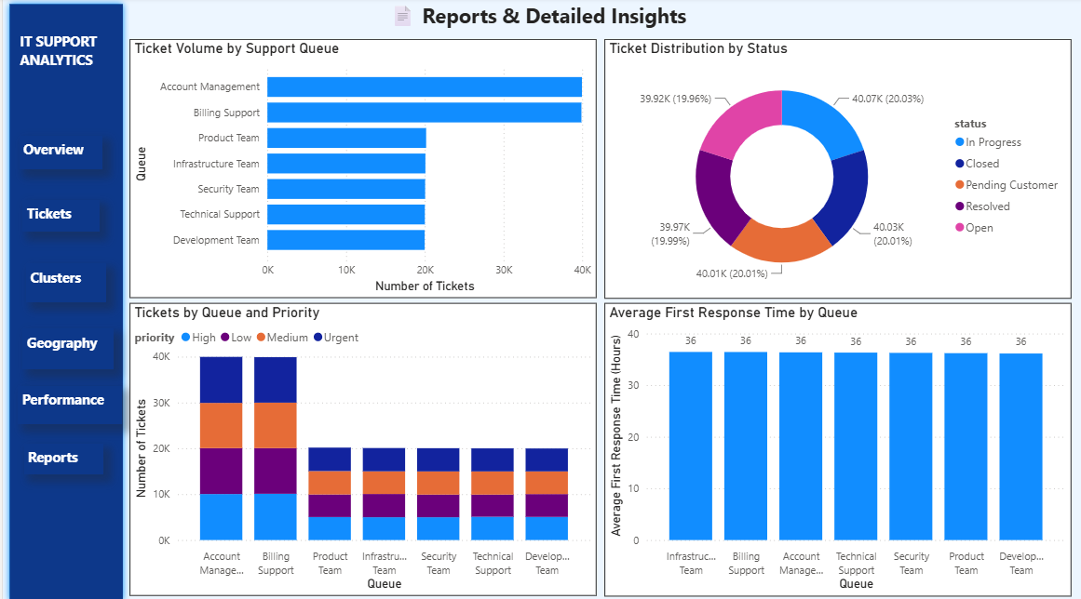

16. Dashboard Design and Interactivity
- Created a left navigation panel for all six pages.
- Configured navigation buttons for Overview, Tickets, Clusters, Geography, Performance, and Reports.
- Used presentation-friendly KPI labels and axis titles.
- Added/defined tooltip information for detailed hover analysis.
- Planned Clear All Filters using slicer defaults and bookmarks after all pages were finalized.

17. Key Findings Supported by the Analysis
- Ticket volume can be compared across categories, products, channels, priorities, statuses, and regions.
- Support queues can be compared using resolution time, performance score, and customer satisfaction.
- Clustering groups tickets into similar analytical patterns.
- Similarity scoring adds information for understanding relationships among ticket issues.
- Geographic analysis highlights regional and category concentration patterns.
- SLA breach and escalation analysis helps identify operational attention areas.

18. How the Project Helps the Support Team
- Improve Resolution Speed – identify faster and slower priorities, teams, and regions.
- Prioritize Critical Issues – identify high-priority and unresolved work.
- Optimize Team and Regional Performance – compare performance and support resource allocation.
- Identify Problem Areas – find regions and issue categories with high concentrations or recurring patterns.

19. Final Deliverables
- Cleaned and processed support-ticket dataset.
- Feature-engineering summary and data dictionary.
- Similarity and K-Means clustering analysis.
- Dataset containing Cluster and Similarity_Score.
- Geographic dataset containing Latitude and Longitude.
- Performance analysis containing Performance_Score.
- Six-page Power BI interactive dashboard.
- Milestone presentation content for data preparation, clustering, performance, and geographic analysis.

20. Conclusion
The project transformed a large IT support-ticket dataset into an analytical solution combining data preparation, feature engineering, text similarity, K-Means clustering, geographic analysis, performance analysis, and Power BI reporting. The final dashboard provides a structured way to monitor ticket patterns, support queues, clusters, geographic distribution, SLA conditions, and performance indicators, helping support teams make more informed operational decisions.

